Fireworks Planning Document

# Description:

This will be a fireworks simulation. The user will click drag and release on the screen to shoot particles that will explode and look like fireworks. Each explosion will be a different color. As the particles fly they will follow a parabolic arc giving the visual appearance of the effect of gravity. The distance between click and release will determine initial speed and direction. Initial location will be the location of release. Background will be black. As particles move they will leave a fading trail behind.

# Screenshot:

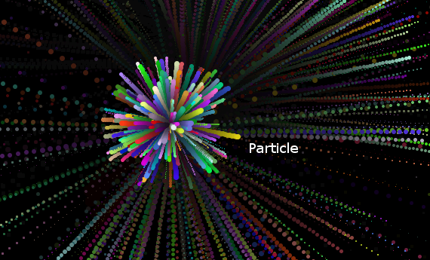

# 

# MileStones / Success Criteria:

1. Get a window to open and display (from template). --done
2. Get a particle to display -- done
3. Get the particle to fall with gravity -- done
4. Create “flying” particles with click and drag. -- done
5. Make particles explode after a period of time -- done
6. Make explosions random colors -- done
7. Add fading trails behind the particles -- done

# Use Cases:

|  |  |  |
| --- | --- | --- |
| **Program initial state** | **Action or event** | **Programs response** |
| Program not yet started | User starts the program | Display a window with a black screen |
| Program is opened nothing displayed in the window | User clicks drags and releases | A particle is displayed at the location of release. It moves across the screen. |
|  |  |  |
|  |  |  |
|  |  |  |
|  |  |  |
|  |  |  |

# 

# Class Diagram:

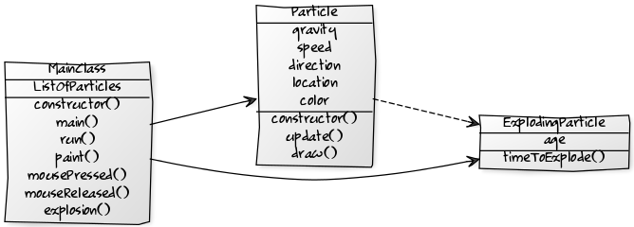

[MainClass|ListOfParticles|constructor();main();run();paint();mousePressed();mouseReleased();explosion()]

[Particle|gravity;speed;direction;location;color|constructor();update();draw();]

[ExplodingParticle|age|timeToExplode()]

[MainClass]->[Particle]

[MainClass]->[ExplodingParticle]

[Particle]-.->[ExplodingParticle]